# Lab 9

1. 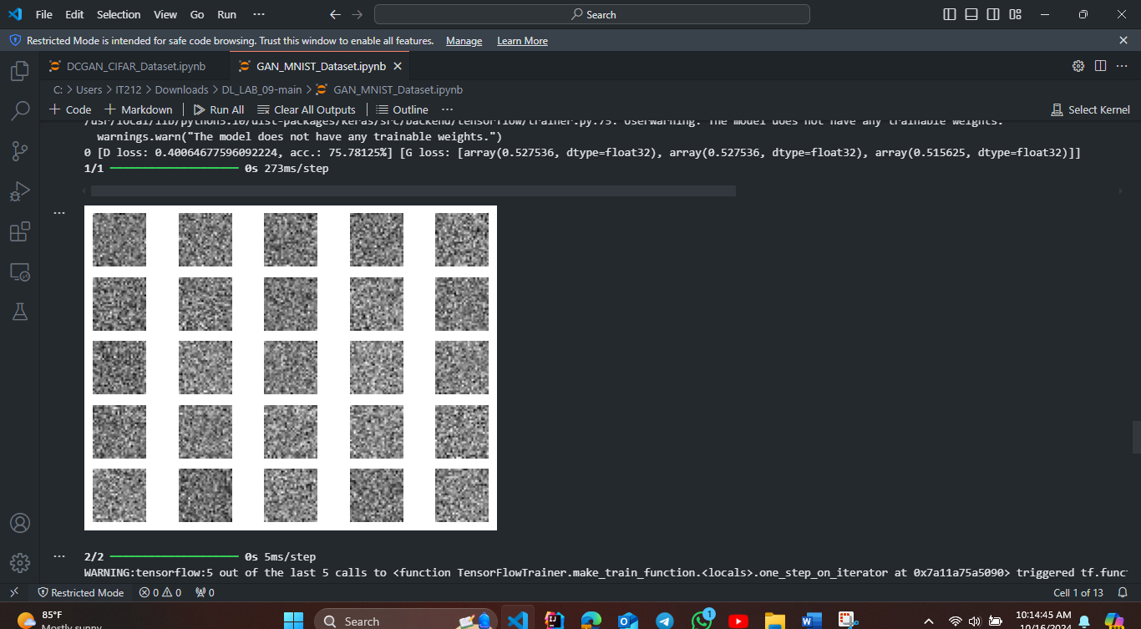Include the visualized results (images, GIFs, etc).

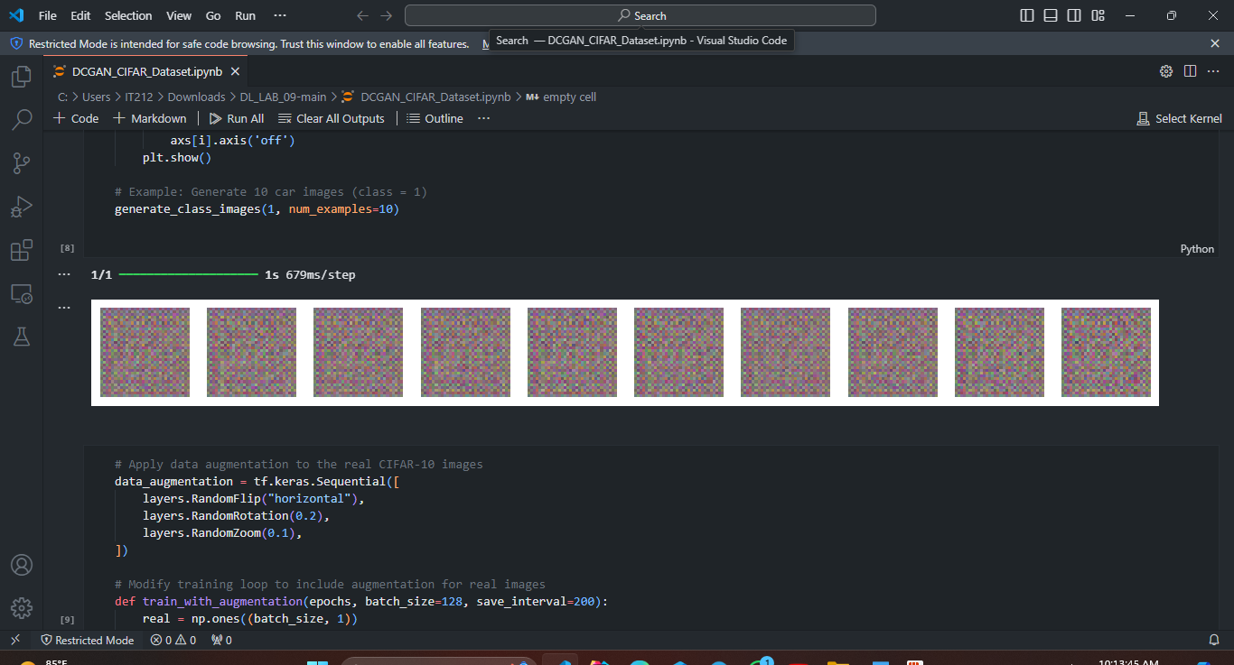

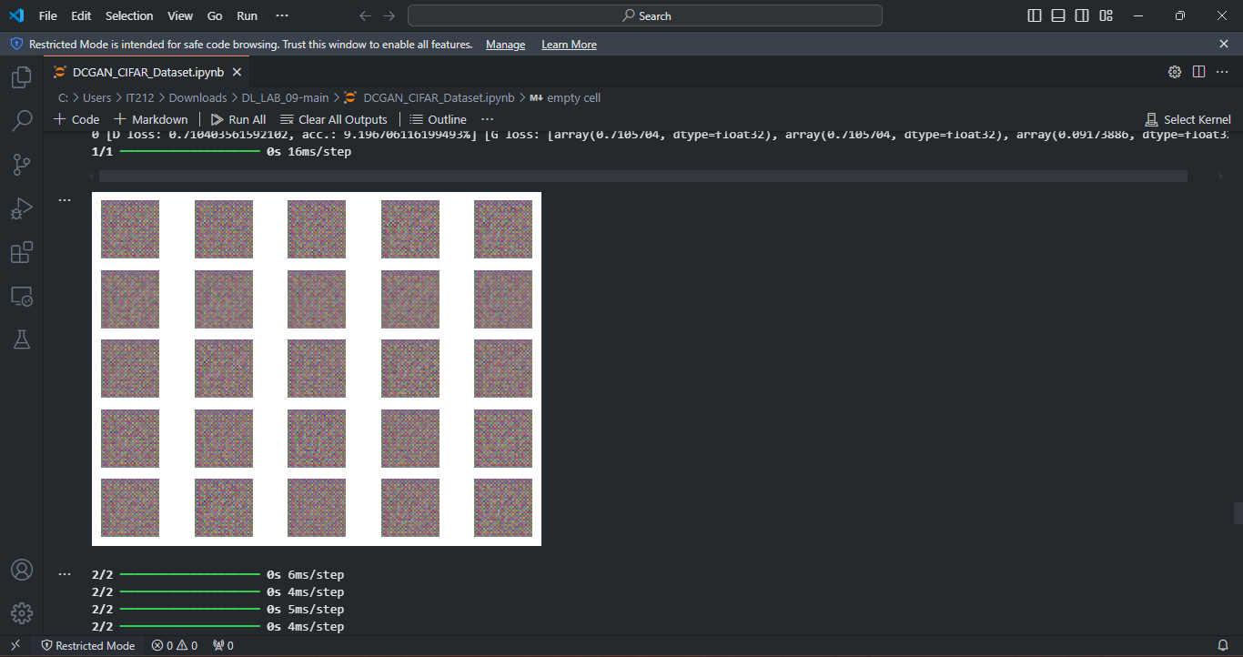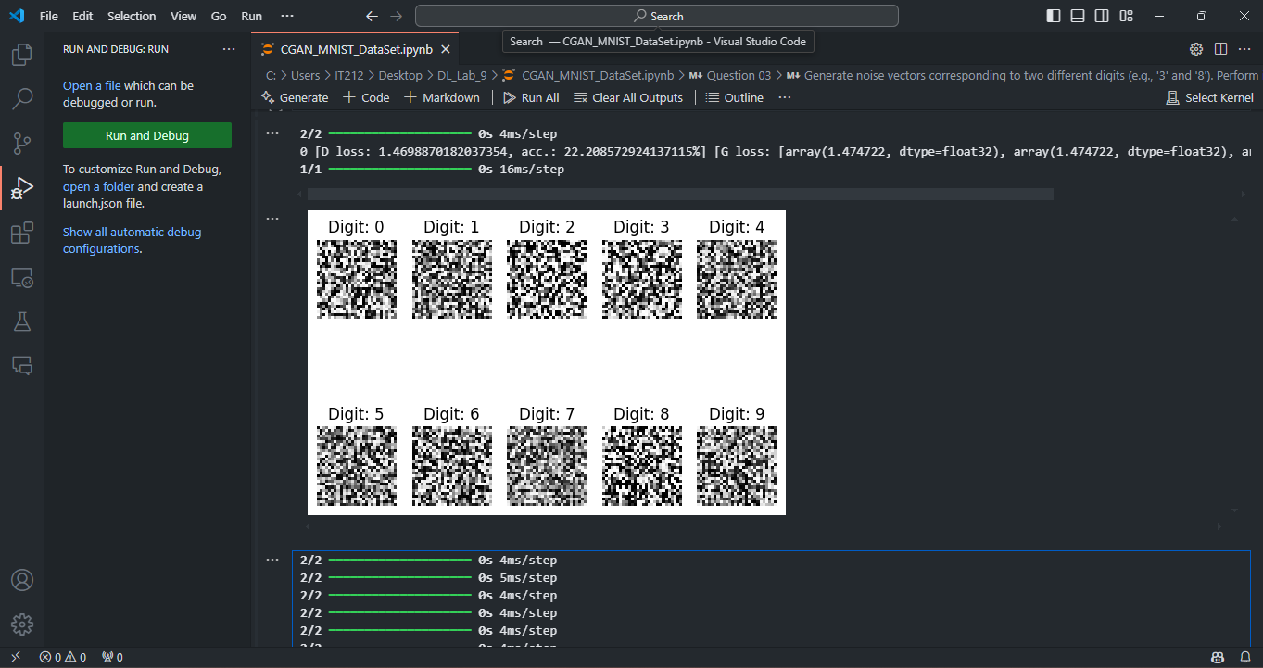

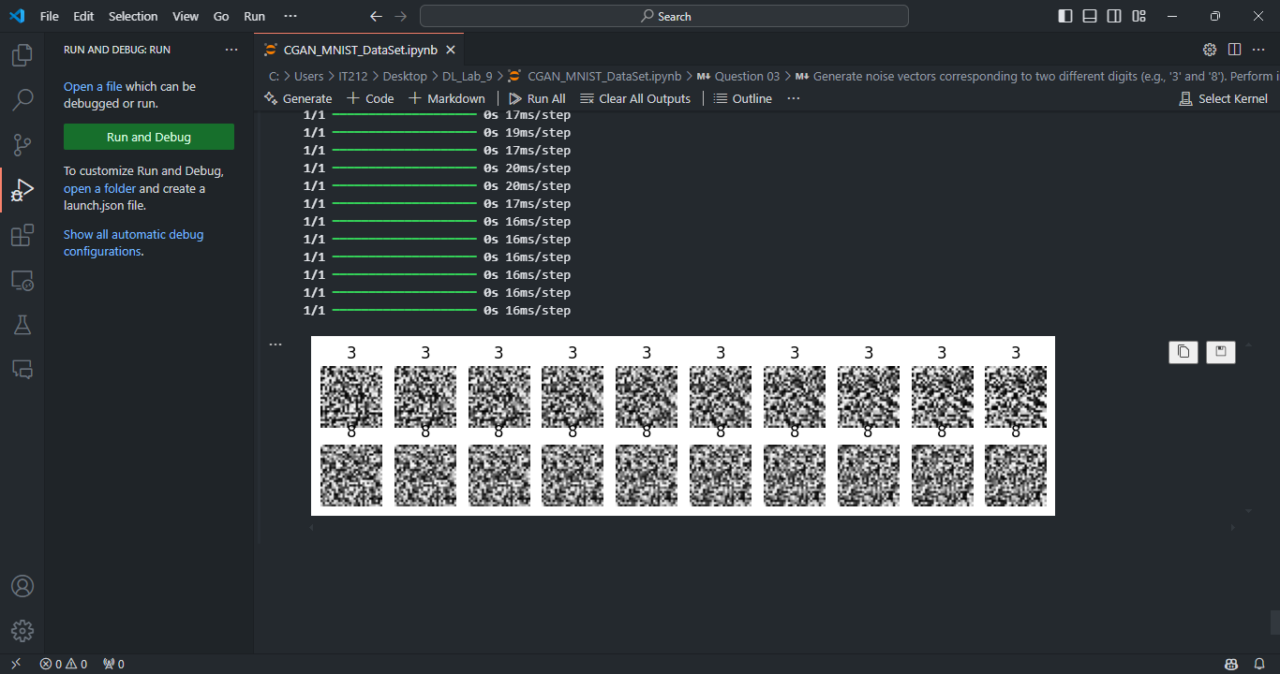

GAN_MNIST_Dataset Notebook

Change Latent Space Size:

What happens: Making the random noise smaller (like 50) gives worse images. Making it bigger (like 200) gives better images but takes longer to train.

Conclusion: The noise size has to be just right. Too small makes bad images, too big makes training harder.

Train for 1000 Epochs (crashed when training)

What happens: The more you train, the better the images get. At the start, the images are random, but over time, they look more real.

Conclusion: Training for a long time helps make good images.

Change Optimizer:

What happens: Changing from Adam to RMSprop or SGD makes training slower and gives worse images. Adam works best.

Conclusion: Adam is the best for training GANs.

Change Batch Size:

What happens: Small batch sizes make training unstable. Bigger batch sizes help with better training but take more time.

Conclusion: Bigger batch sizes give better results, but take longer.

CGAN_MNIST_Dataset Notebook

Generate Specific Digits:

What happens: When you make the GAN focus on certain digits (like '7' or '9'), it learns to generate only those numbers.

Conclusion: You can control what the GAN creates by telling it which digit to generate.

Label Smoothing:

What happens: Replacing the label "1" with numbers between 0.9 and 1 makes training better, and images look nicer.

Conclusion: Label smoothing helps make better images.

Morph Between Digits:

What happens: Blending two different digits (like '3' and '8') changes one image into the other. It shows how the GAN learns to create different images.

Conclusion: GANs can smoothly change one type of image into another.





DCGAN_CIFAR_Dataset Notebook

Generate Specific Classes:

What happens: When you train the GAN to make specific things (like cars or airplanes), the quality depends on how well the model learns. Sometimes they look good, sometimes not.

Conclusion: GANs can make specific images, but the quality might vary.

Data Augmentation:

What happens: Adding changes like flipping and cropping to real images makes the GAN learn better and create more realistic images.

Conclusion: Changing real images during training can make the GAN create better images.

Inception Score (IS):

What happens: The IS score tells you if the images are good. Higher scores mean better images. You can check the score after 2,000, 5,000, and 10,000 epochs to see if the images improve.

Conclusion: The IS score helps you see if the GAN is getting better.

Add More Layers:

What happens: Adding more layers to the GAN **probably** can make better images, but it makes training slower and harder.(crashed)

Conclusion: More layers can improve image quality, but training becomes more complicated.

